**LIGHT POLLUTION**

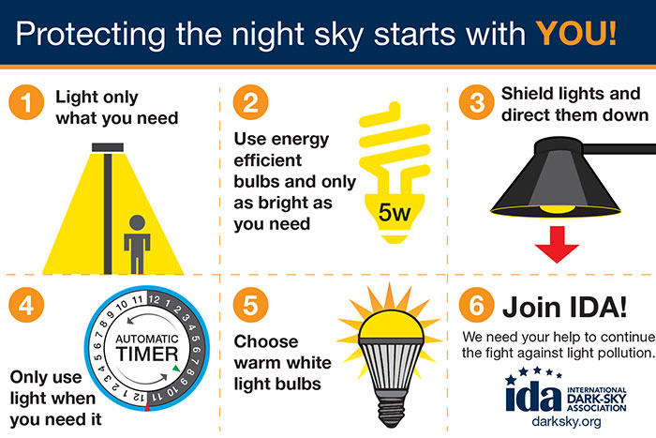

<https://www.darksky.org/wp-content/uploads/2016/03/Postcard-back-web-300x200.jpg>

Light pollution is the presence of anthropogenic and artificial light in the night environment. It is exacerbated by excessive, misdirected or obtrusive use of light, but even carefully used light fundamentally alters natural conditions. As a major side-effect of urbanization, it is blamed for compromising health, disrupting ecosystems and spoiling aesthetic environments.

The term is most commonly used in relation to in the outdoor environment, but is also used to refer to artificial light indoors. Adverse consequences are multiple; some of them may not be known yet. Light pollution competes with starlight in the [night sky](https://en.wikipedia.org/wiki/Night_sky) for urban residents, interferes with [astronomical](https://en.wikipedia.org/wiki/Astronomy) [observatories](https://en.wikipedia.org/wiki/Observatory), and, like any other form of [pollution](https://en.wikipedia.org/wiki/Pollution), disrupts [ecosystems](https://en.wikipedia.org/wiki/Ecosystem) and has adverse health effects.

Light pollution is a side-effect of industrial civilization. Its sources include building exterior and interior lighting, advertising, outdoor area lighting (such as car parks), offices, factories, streetlights, and illuminated sporting venues. It is most severe in highly industrialized, densely populated areas of [North America](https://en.wikipedia.org/wiki/North_America), [Europe](https://en.wikipedia.org/wiki/Europe), and [Japan](https://en.wikipedia.org/wiki/Japan) and in major cities in the [Middle East](https://en.wikipedia.org/wiki/Middle_East) and [North Africa](https://en.wikipedia.org/wiki/North_Africa) like [Tehran](https://en.wikipedia.org/wiki/Tehran) and [Cairo](https://en.wikipedia.org/wiki/Cairo), but even relatively small amounts of light can be noticed and create problems. Awareness of the deleterious effects of light pollution began early in the 20th century, but efforts to address effects did not begin until the 1950s. In the 1980s a global [dark-sky movement](https://en.wikipedia.org/wiki/Dark-sky_movement) emerged with the founding of the [International Dark-Sky Association](https://en.wikipedia.org/wiki/International_Dark-Sky_Association) (IDA).

How can we help prevent it?

* Only be on when needed
* Only light the area that needs it
* Be no brighter than necessary
* Minimize blue light emissions
* Be fully shielded (pointing downward)

For more information visit: <https://www.darksky.org/>

**Space Debris**

"The Universe is infiniteBut space has its limitsRockets a launchingSat’lites are orbitingExplosions in SpaceOh what a wasteFragments go flyingAnd we go crying “Space junk we’ve got” Man-made or notThen comes Kessler Who knows the betterWhen things collideTheir debris do multiplyThanks to partneringAnd NASA’s gatheringWe look for waysTo manage the spray"  
- S. Thuy Nguyen-Onstott.

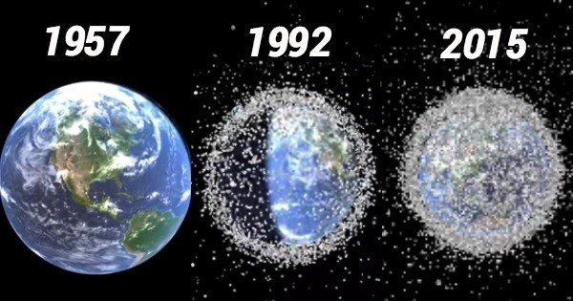

It is actually littered with waste, some of which were **caused** by human activity. **Debris** in **space** is called **space** junk or orbital **debris** because they orbit the Earth. They are made up of items such as used-up rocket stages, loose fragments from rocket explosions and collisions, launch canisters, dust and paint flakes.

**Space** junk can **impact** other objects at over 22,300 mph, faster than a speeding bullet. Collisions with those tiny pieces often leave pits and dings in the many satellites, telescopes, and other objects orbiting our planet.

The most effective shortterm means of reducing the **space debris** growth rate is through the **prevention** of inorbit explosions (via passivation of **space** objects at the end of their operational life) or collisions (via collision avoidance manoeuvres while the objects are still active).

For more information visit: <https://www.nasa.gov/mission_pages/station/news/orbital_debris.html>